
RM of Prairie Lakes
https://www.rmofprairielakes.ca/
Self-Guided Tour #6

Margaret & Nearby

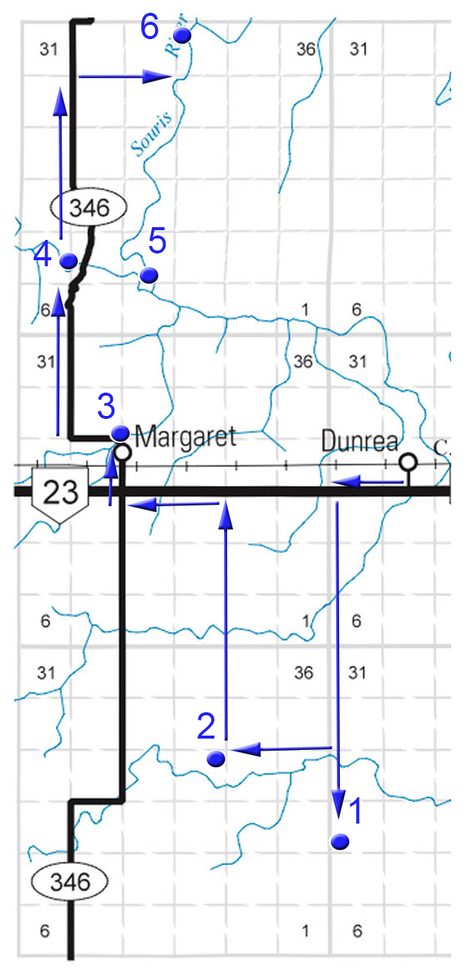

For the online version and additional information, visit:

www.virtualmanitoba.com/prairielakes/

1. Rowland Church and School

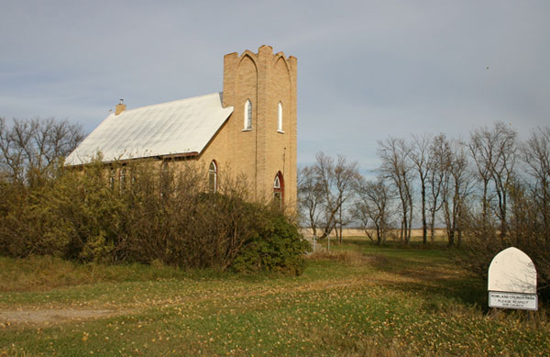

In 1882 a thriving town was located near this site. In 1885, the railway passed though Killarney. Rowland as a town was doomed, but Rowland as a community persisted.

Rowland United Church, built in 1912 for a Methodist Congregation, remains as a reminder of that community.

N 49.29676, W 99.78814

2. Poverty Hill / Russell Family Monument

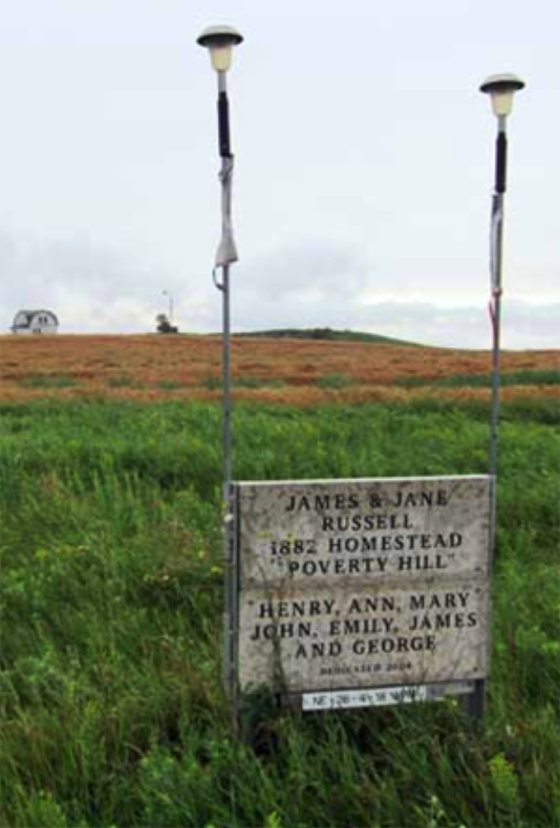

Rowland area homesteader James Russell named his farm “Poverty Hill”. A cairn marks the spot on NE 26- 4-18.

N 49.34038, W 99.78884

3. Margaret Village
In 1891, pioneer John Magwood applied for and received a Post Office, which he named Margaret after his mother. It was located in his home, about a kilometre north of the current village. Margaret was registered as a village in 1900.

King’s United Church

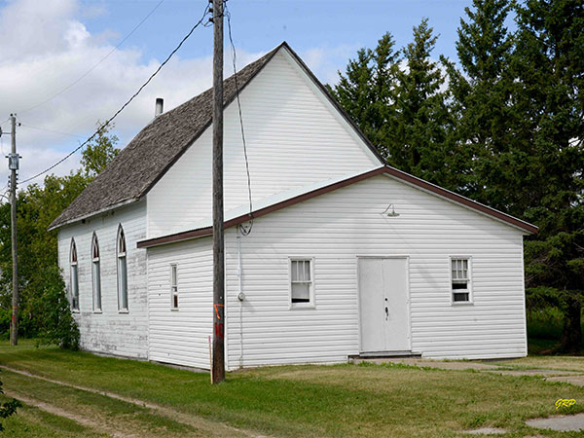

King’s United Church, built in 1900, was named in honour of Rev. John King, the first Principal of Manitoba College. At first Presbyterians and Methodists shared the facility. They began worshiping together long before Church Union in 1925.

The Rink

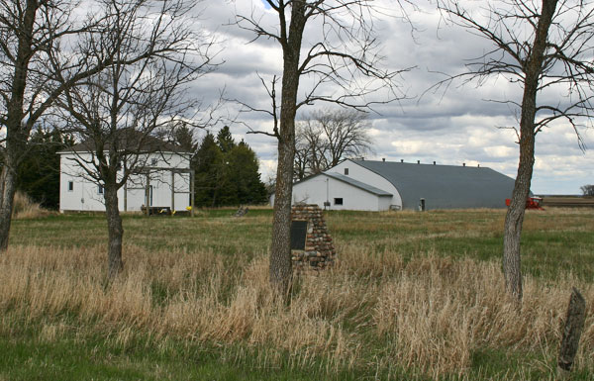

The rink was built in 1947 using Dring rafters from Boissevain.

The School Yard

A monument dedicated in 1970 on the site of the Margaret School, celebrates the region’s original schools.

The Nelson Creek Bridge

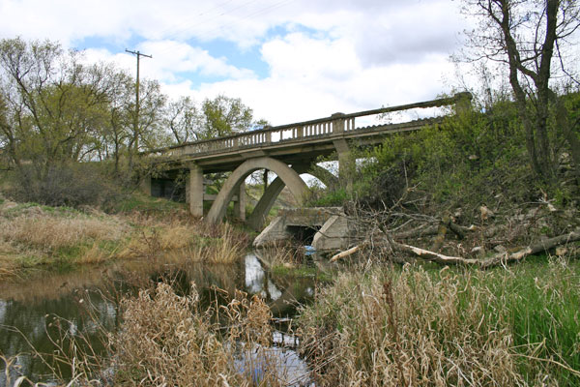

This abandoned concrete arch bridge over Nelson Creek was constructed between 1916 and 1917 just north of Margaret.

Margaret Cemetery

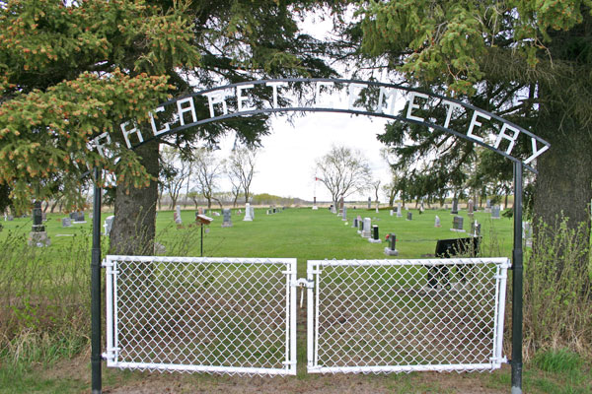

The first burial in the Margaret Cemetery was William McKellar, in 1888

N 49.41442 W 99.85717

This cemetery contains a monument, unveiled in June 1921, commemorating men of the local area killed during military service in the First World War and Second World War.

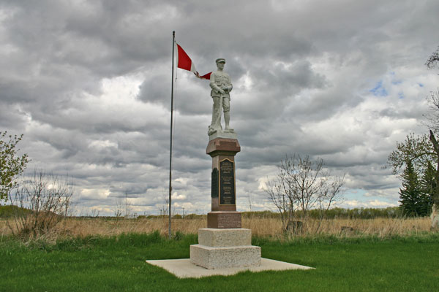

The first verse of “In Flander’s Fields” is inscribed on the base.

4. McKellar’s Bridge

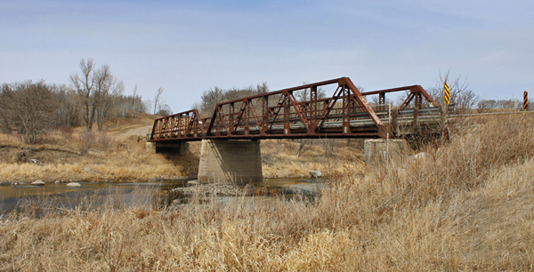

The main crossing of the Souris River in the region along provincial road #346 north of Margaret. From the south this is the route to Lang’s Crossing and then Gregory’s Mill.

N 49.46195, W 99.87368

The Souris Bend Wildlife Management Area

The lands that make up the WMA were formally designated in 1968. It consists of over 2000 hectares over a beautiful and historic landscape. The following two sites are just a part of what the area has to offer.

5. Lang’s Crossing

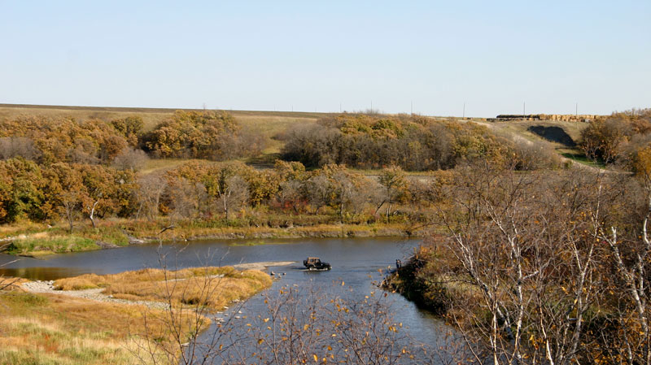

Pioneer trails crossed the Souris River at this spot. A rough trail is accessed from RD 346, just north of McKellar’s Bridge, but hiking is the best way to appreciate the landscape.

N 49.450667 W 99.829892

6. Gregory’s Mill

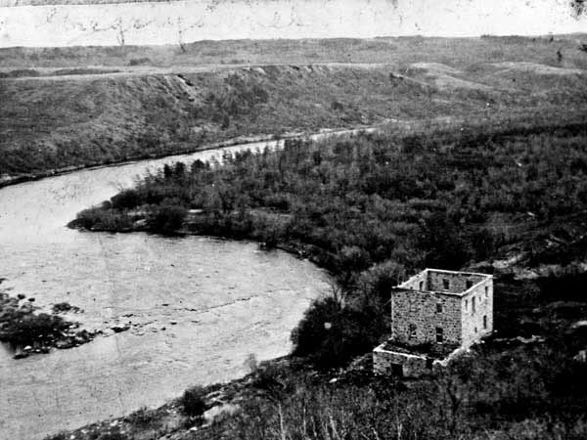

Gregory’s stone mill, provided flour for the settlers in the area for over a decade.

All that remains at the site are a few remnants of foundations hidden in dense bush, and the overgrown millrace, a ditch about two metres deep and over a kilometre in length. You can drive to the trailhead for a magnificent view, but seeing the mill site requires some hiking
over steep trails. It is well worth it.

Trail head - N 49.514579 W 99.839701
Mill Site- N 49.52416, W 99.82861

